Short Term Memory Investigation Validation

Name____________________________________________________

Mark___/15

For the investigation YOU and your group carried out on short term memory state the variables listed below.

1. Independent variable

=_____________________________________________________________________________________________________________

1. Dependent variable

=_____________________________________________________________________________________________________________

1. One controlled variable

=_____________________________________________________________________________________________________________

(3 marks)

A significant number of elderly people live with mild memory problems that are part of the normal aging process. Although many of these problems only mildly interfere with daily life, they may be troublesome to the person experiencing them.

Here are some results for a memory test where people of different ages are were asked to remember words in a list.

|  |  |
| --- | --- |
| Age(years) | Number of words remembered from a list of 25 words |
| 20 | 14 |
| 30 | 13 |
| 40 | 10 |
| 50 | 10 |
| 60 | 8 |

(Data from NYU Langone Medical Centre)

Use the data in the table on the previous page to answer the questions that follow.

1. For this investigation what where the:
2. Independent variable?

=_______________________________________________________________________________________________________

1. Dependent variable?

=_______________________________________________________________________________________________________

1. Can you suggest ONE variable that needed to be controlled in this investigation?

=__________________________________________________________________________________________________________________________________________________________________________________________________________________________________________________________________________________

(3 marks)

1. Can you suggest a possible hypothesis for this investigation?

=__________________________________________________________________________________________________________________________________________________________________________________________________________________________________________________________________________________

(2 marks)

1. Construct a suitable graph for the data in the table on the first page of this validation.

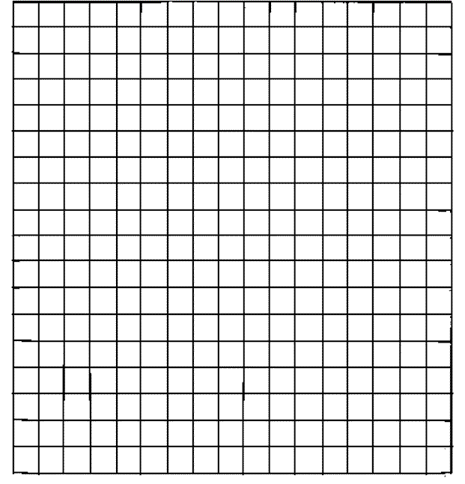

(5 marks)

1. Give a reason for drawing the type of graph you did.

_____________________________________________________________________________________________________________.

(2 marks)